Chemistry 1108 Final Exam
Name:
CRN:

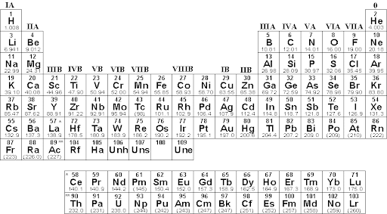

Points earned
Identification
Measurement
Lab Technique
Graphical Analysis
Data Analysis
Total points

1. Identification:
- Classify the following mixtures as homogeneous (solutions) or heterogeneous:
 | Homogeneous or heterogeneous | 0 points | 1 point
Mixture 1 |  | incorrect | correct
Mixture 2 |  | incorrect | correct
Mixture 3 |  | incorrect | correct
Mixture 4 |  | incorrect | correct

- Match the glassware to the label.
 | 0 points | 1 point | 2 points
250 mL Erlenmeyer flask | Wrong equipment | Wrong size | Correct equipment and size
50 mL beaker | Wrong equipment | Wrong size | Correct equipment and size
Burret clamp | Wrong equipment |  | Correct equipment and size
Weighing boat | Wrong equipment |  | Correct equipment
Burret | Wrong equipment |  | Correct equipment
Side arm flask | Wrong equipment |  | Correct equipment
Buchner Funnel | Wrong equipment |  | Correct equipment
Pipette | Wrong equipment |  | Correct equipment
100 mL Volumetric Flask | Wrong equipment | Wrong size | Correct equipment and size
Magnetic stir bar | Wrong equipment |  | Correct equipment

2. Measurement:
- Weigh out 2.5 g of NaCl. Record your final measurement: __________________
- Record the volume of a liquid in a 10 mL graduated cylinder: ________________
- Record the volume of a liquid in a 50 mL graduated cylinder: ________________
- Record the temperature of a liquid using a thermometer: ___________________
 | 0 points | 1 point | 3 points | 5 points
Weigh out 2.5 g of NaCl. | Unable to perform skill | Within ±0.50 g and not recorded | Within ±0.10 g and recorded with mistakes | Within ±0.10 g and recorded correctly
Record the volume of a liquid in a 10 mL graduated cylinder. | Wrong number | Wrong sensitivity and no units | Wrong sensitivity or no units | Correct
Record the volume of a liquid in a 50 mL graduated cylinder. | Wrong number | Wrong sensitivity and no units | Wrong sensitivity or no units | Correct
Record the temperature of a liquid using a thermometer. | Wrong number | Wrong sensitivity and no units | Wrong sensitivity or no units | Correct

3. Basic lab technique with waste disposal:
- Select all the equipment for Buchner filtration. Demonstrate how it works.

- Select all the equipment and materials required for titrating an acid with a base. Demonstrate how it works.

- Select all the equipment and materials required to make a 1.0 M NaOH solution. Describe how it is done.

- Select all the equipment and materials required to make a 0.25M NaOH solution from a 1.0M solution. Demonstrate how it is done. Calculate the pH and pOH.

- Select all the equipment and materials required to make a 1.0 m NaOH solution. Describe how it is done. How could this become a buffer solution?

- Select all the equipment and materials required to perform an electrolysis of water. Describe how it is done. What is the sign of delta G for this reaction?

 | 0 points | 1 point | 3 points | 5 points
Buchner filtration | Unable to start | Major mistakes | Small mistakes | Correct
Titration | Unable to start | Major mistakes | Small mistakes | Correct
1M solution | Unable to start | Major mistakes | Small mistakes | Correct
Dilution | Unable to start | Major mistakes | Small mistakes | Correct
1m solution | Unable to start | Major mistakes | Small mistakes | Correct
Electrolysis | Unable to start | Major mistakes | Small mistakes | Correct

Chemistry 1108 Final Exam
Name:
CRN:

4. Graphical Analysis:
- For each titration curve shown:
    - Identify it as a strong acid-strong base, strong base-strong acid, weak acid-strong base or weak base-strong acid.
    - Identify the equivalence point on the graph and note it in the box on the right. Show how it was found.
    - If there is a buffer region, identify it on the graph and note the buffer range in the box to the right. If there is none, write NONE in the box to the right.
    - If there is a pKa, identify it on the graph and note it in the box to the right. If there is none, write NONE in the box to the right.

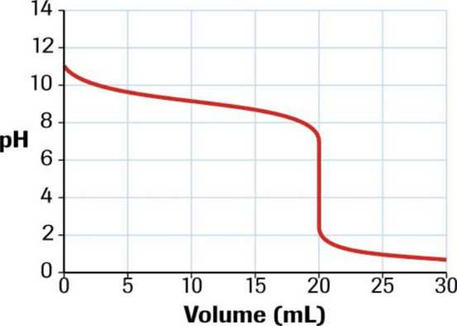 | I
 | II
 | III
 | IV
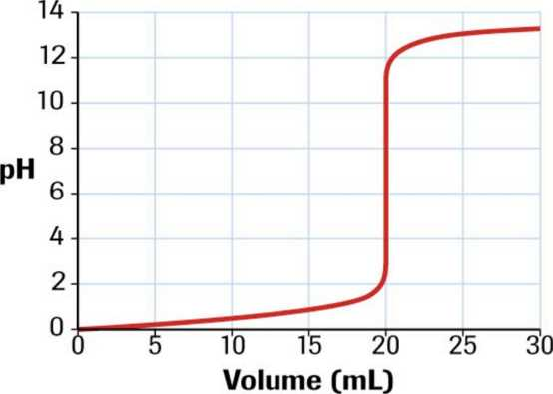 | I
 | II
 | III
 | IV
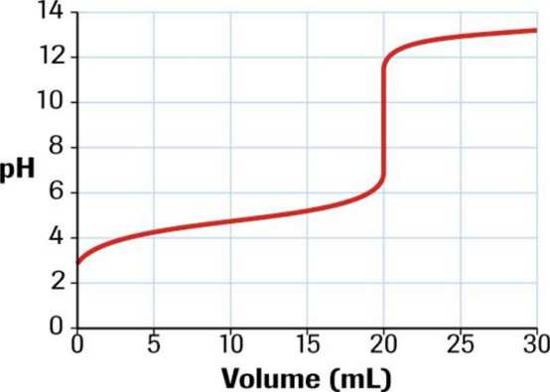 | I
 | II
 | III
 | IV
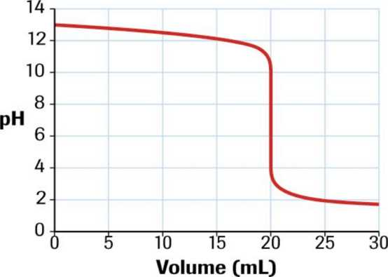 | I
 | II
 | III
 | IV

1 point each | Identification | Equivalence point | Buffer region | pKa | Total correct
Titration curve 1 | Identified or not identified | Identified or not identified | Identified or not identified | Identified or not identified
Titration curve 2 | Identified or not identified | Identified or not identified | Identified or not identified | Identified or not identified
Titration curve 3 | Identified or not identified | Identified or not identified | Identified or not identified | Identified or not identified
Titration curve 4 | Identified or not identified | Identified or not identified | Identified or not identified | Identified or not identified

5. Data Analysis:

- 10.5 grams of ethylene glycol (C₂H₆O₂) was dissolved in 100 grams of water and placed in the freezer. At what temperature would you expect the solution to freeze? K_{f} for water is 1.86ºC/m and K_{b} for water is 0.512(ºC/m) Show your work.

- Determine rate law, order of reaction, rate constant from the equation and kinetics data below. Show your work.
Determine rate law
order of reaction,
rate constant

NO₂(g) + CO(g) NO(g) + CO₂(g)

[NO₂](M) | [CO](M) | initial Rate (M/s)
0.10 | 0. 10 | 0.0021
0.20 | 0. 10 | 0.0082
0.20 | 0. 20 | 0.0083
0.40 | 0.10 | 0.033

- In the lab, solid CaF₂ was dissolved in water until a solution with a concentration of 6.04 x 10⁻⁶M was attained. When additional CaF₂ was added, it precipitated.
What is the Ksp? Show your work.

What is the molar solubility of CaF₂ in a 0.100M solution of NaF?

Explain addition of NaF in terms of Le Chatelier’s principle.

- A reaction is carried out in lab with 1.50 grams of CuSO₄ -5H₂O and 20 mL of 9.0M NH₃ according to the equation. The product was collected and weighed. There were 0.084 grams.
CuSO₄-5H₂O) + 4NH₃ [Cu(NH₃)₄]SO₄-H₂O
In each part show your work to receive credit.
- Identify the limiting reactant.

- Calculate the theoretical yield.

- Calculate the percent yield.

 | 0 points | 1 point | 3 points | 5 points
Freezing point | Unable to start | Major mistakes | Small mistakes | Correct
Rate Law | Unable to start | Major mistakes | Small mistakes | Correct
Ksp and Le Chatelier | Unable to start | Major mistakes | Small mistakes | Correct
Percent yield | Unable to start | Major mistakes | Small mistakes | Correct

