

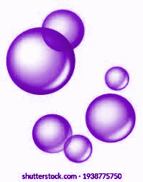
pH Color Potion

Chemical Name | Amount Used
Deionized water | 300 mL
Red cabbage | Enough to fill the beaker

Equipment Name | Number of Items
Large beaker (600 mL) or pot | 1
Smaller beaker (250 mL) or cup | 1
Small cup (3oz)
Strainer | 1
Hot plate or stove | 1

Beaker 1 - Create the water and cabbage solution
- Pour 300 milliliters of water in the large beaker.
- Place the beaker on the hot plate and turn on the heating.
- Tear leaves of the red cabbage into smaller pieces and place them into the beaker of water-use as many leaves as can fit.
- Wait until the water reaches a boil.


- Once the solution is dark enough, turn off the hot plate. Wait for the beaker to cool completely before handling.
6. Place the strainer over the smaller beaker and slowly pour the cabbage and water mixture through the strainer to separate the liquid from the leaves.
Experiment
- Add a spoonful of the solution in a small cup.
- Add a small amount of vinegar, lemon juice, baking soda, baking powder, etc into individual cups with the red cabbage extract and observe the color.
- Label and refrigerate or freeze the leftover cabbage solution for later use.

