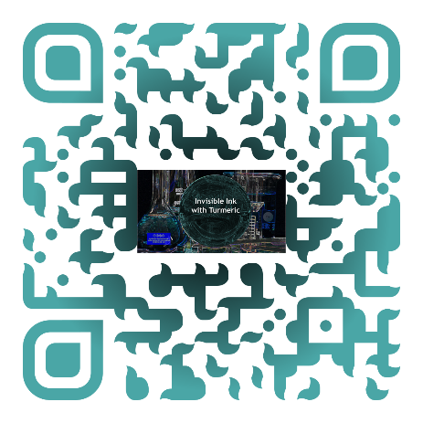


pHantom Messages

Chemical Name | Amount Used
Turmeric powder | ½ a teaspoon
Hand sanitizer | 2-3 mL
Sodium Carbonate (or baking soda/sodium hydroxide) | 22g in 100 mL of water
Distilled water | As needed

Equipment Name | Number of Items
Filter paper | 1 sheet
Paint brushes | 2 (or 1 if rinsed between uses)
Small containers | 2
Stirrer or spoon | 2
Airstream or area to dry | Optional


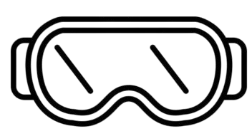

Cup 1 - Prepare the indicator solution
Place 1/2 teaspoon of turmeric into a small container. Add 2-3 mL of hand sanitizer into the container. Use a stirrer or spoon to mix until fully mixed.


Cup 2 - Prepare the invisible ink
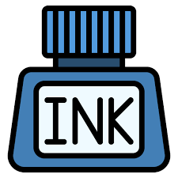
Create the sodium carbonate solution by dissolving 22g of sodium carbonate in 100 mL of distilled water in a small container. Mix using a stirrer or spoon until fully dissolved.

Experiment
- Write your secret message

Dip a paintbrush into the sodium carbonate solution. Then write or draw a message on the filter paper. Be careful not to overlap strokes or oversaturate the filter paper.
- Dry the paper
Let the paper air dry completely or place it near an airstream for quicker drying.
- Reveal the secret message
Dip a clean paintbrush into the turmeric and hand sanitizer solution. Paint the solution over the dry filter paper. Watch the secret message reveal itself.

