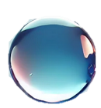
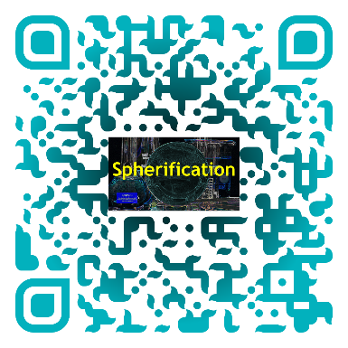
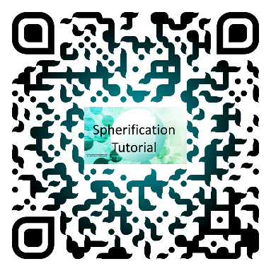

Stellar Spheres
Tactile Version

Chemical Name | Amount Used
Sodium alginate solution | 1 gram in 100 mL of water
Calcium lactate solution | 2 grams in 150 mL of water
DI water | 150 mL
Food coloring | 1 drop
Edible glitter | optional

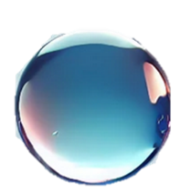
Equipment Name | Number of Items
50 mL graduated cylinder | 1
8 oz cups | 2
Slotted spoon or spork | 1
Scale | 1
Syringe | 1
3 oz cup | 1
Stirrer | 1

Cup 1
In the small cup collect the prepared sodium alginate solution with the food coloring and glitter.

Cup 2
Measure 2 grams of calcium lactate in a large cup using the scale. Add 150 mL of water and stir until all the calcium lactate dissolves. Add a rubber band around the cup.

Cup 3
Measure 150 mL of water in the other large cup.

Experiment
Fill your syringe with the sodium alginate gel from the small cup and add it to the cup with the rubber band as droplets.
Wait at least 45 seconds before extracting the drops from the cup with the rubber band and transfer them into the water from the cup without the rubber band to wash off the extra calcium lactate.
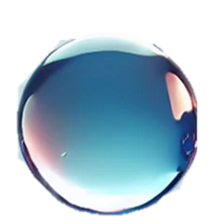
Once rinsed, you can fish out your spheres onto a paper towel!

