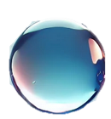
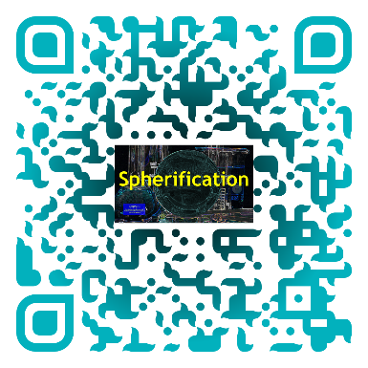
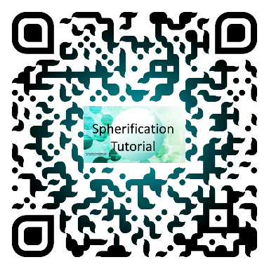

Stellar Spheres

Chemical Name | Amount Used
Sodium alginate solution | 1 gram in 100 mL of water
Calcium lactate solution | 2 grams in 150 mL of water
DI water | 150 mL
Food coloring | 1 drop
Edible glitter | optional

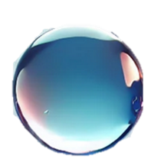
Equipment Name | Number of Items
50 mL graduated cylinder | 1
8 oz cups | 2
Slotted spoon or netting | 1
Scale | 1
Syringe | 1
3 oz cup | 1
Stirrer | 1

Cup 1
In the 3 oz cup collect the prepared sodium alginate solution with the food coloring and glitter. Label the cup with number 1.

Cup 2
Measure 2 grams of calcium lactate in an 8 oz cup using the scale. Add 150 mL of water and stir until all the calcium lactate dissolves. Label the cup with the number 2 and place the net inside the cup.

Cup 3
Measure 150 mL of water in an 8 oz cup and label it with the number 3.

Experiment
Fill your syringe with the sodium alginate gel from cup 1 and add it to cup 2 either as droplets or other shapes while submerging the tip.
Wait at least 45 seconds before using the net to lift the shapes and drops out of cup 2 and transfer its contents into the water in cup 3 to wash off the extra calcium lactate.
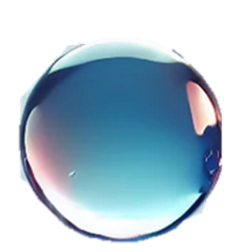
Once rinsed, you can fish out your shapes and drops, and experiment with them!

