

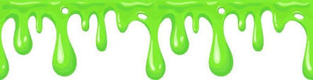
Slime Time!

Chemical Name | Amount Used
Multi-purpose solution (contact solution) | 10 mL
Glue | 30 g
Sodium carbonate (baking soda) | 4 g
Food color | 2 drops
Deionized water | 20 mL
Shaving cream (optional) | Increments of choice

Equipment Name | Number of Items
Scale | 1
Graduated cylinder (50 or 25 mL) | 1
Mixing container (plastic cup) | 1
Stirring rod | 1
Weighing boat | 1

Experiment

Weigh the glue
Tare a clear cup on the scale and measure 30 grams of glue into it.

Measure the baking soda

Tare a weighing boat on the scale and measure about 4 grams of baking soda.

Combine water and glue
Measure about 20 milliliters of deionized water using the graduated cylinder. Pour this into the cup with glue. Mix the two using the stirring rod.

Color the slime
Add two drops of desired color food coloring to the cup and mix using the stirring rod to distribute it evenly.

Add the baking soda
Dump the baking soda from the weighing boat into the cup and mix the solution again.

Add the multi-purpose solution
Measure about 10 milliliters of multi-purpose solution using the graduated cylinder and pour the solution in the cup.

Form slime
Using the stirring rod, stir the contents until it clumps together, turning into slime. Continue mixing to form a more uniform composition.

Additional steps (optional)
Add increasingly smaller or larger increments of water, baking soda, glue, and multi-purpose solution. You may add small or large amounts of shaving cream for a different texture.

