Shine On

Electromagnetic spectrum:
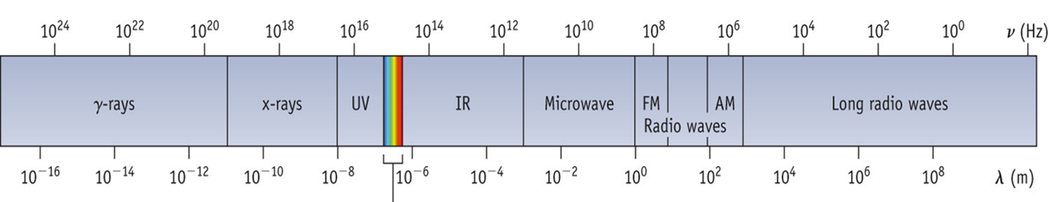
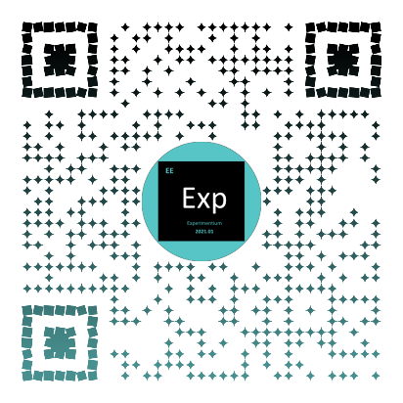
Demonstration video: Idea launchers:
- Names five different kinds of waves.
- How are all the waves the same?
- How are the waves different?
- Which types of radiation do you recognize in the provided spectrum?
- Which color has the shortest wavelength (λ) according to the spectrum?
- Why does a CD or DVD look like a rainbow of colors when you look at it?

Wave illustration:
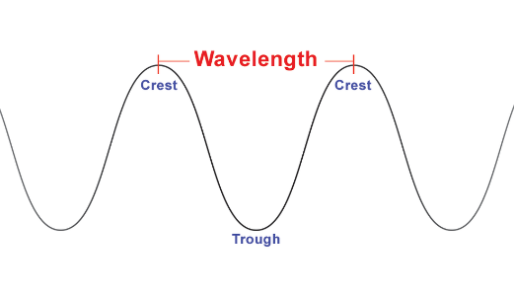
Landing pad:
- Did you see different things with different light sources?
- Did you see emission or absorption spectra?
- How was sunlight different from the discharge tubes?
- If your shirt looks blue, what color does it absorb?
- What color would you predict the sky to look in a forest fire area?
- What similarity did you notice between the wavelength of the visible light and the spacing in your CD?

Rays of knowledge:
- Light is energy that comes from the sun as a continuous spectrum. We can see how this white light separates into colors and produces a rainbow when there are small water droplets in air.
- Lots of things can happen to light as it travels.
It can be transmitted - passes through something like clear glass.
It can be reflected - bounces back like what a mirror does.
It can be refracted - bent and changed like when the light goes from air to water, like when you look through a clear glass at a straw that is ½ in a glass of water, and it looks like the parts of the straw in and out of the water are not connected.
It can be absorbed - captured by something and not returned. If your shirt looks red, it is because it absorbs green light.
It can be scattered - gas molecules and dust send light in every direction. Blue is scattered more than other colors, and the sky looks blue. If there is smoke in the air, or when the sun is near the horizon, so there is extra atmosphere to pass through, the blue scatters so much that we start to see the red and yellow wavelengths.
It can be diffracted - happens when the light waves are bent around openings. The greater the wavelength, the more the diffraction.
- Different light sources give off different wavelengths of light. One way to see the different light is to bend it into its component wavelengths. This can be done using a diffraction grating.
- CD is made of plastic and has lots of tiny grooves. Each groove is 1.6 microns or 1.6×10⁻⁶ m apart. As the light passes through the grooves, it is bent. Longer wavelengths are bent more than shorter wavelengths.
- Absorption spectrum looks like a dark background with light colored lines.
- Emission spectrum looks like a rainbow of colors with dark lines.
- Applications Both emission and absorption spectra are like fingerprints for the different elements. If you can’t take a sample of a star, like the stars, you can tell their composition by looking at the spectra of the light that is given off. This is how helium was discovered.

More on this topic:
Electromagnetic Radiation: Energy of Electromagnetic Radiation:
