


Rainbow Reactions

Chemical Name | Amount Used
Lemon juice | Small amount (in cup)
Vinegar | Small amount (in cup)
Baking soda solution | Small amount (in cup)
Indicator solution | Enough to fill 3 pipettes
Additional chemicals (optional) | Small amount (in cup)
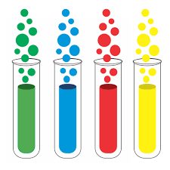
Equipment Name | Number of Items
Test tubes or small cups (3oz) | 3
Pipettes or droppers or spoons | 3 (or 1 if cleaned between uses)
Pipette for indicator solution | 1
Hot plate or stove | 1
Small plastic cup | 3
Procedure
- Label each test tube: “Vinegar”, “Lemon Juice”, and “Baking Soda”.
- Pour each substance into separate cups.
Test tube 1 - Vinegar
- Use a pipette to transfer vinegar into the labeled test tube.
- Add the red cabbage indicator using the indicator pipette.
- Observe the color change.
Test tube 2 - Lemon juice
- Use a clean pipette to transfer lemon juice into the labeled test tube.
- Add the red cabbage indicator using the indicator pipette.
Test tube 3 - Baking soda solution
- Mix baking soda with deionized water to create a saturated solution in a small cup.
- Add the red cabbage indicator using the indicator pipette.

Optional - Test your own household chemicals
For each new substance:
- Pour a small amount into a clean plastic cup.
- Use a clean pipette to transfer it into a clean test tube.
- Add the red cabbage indicator using the indicator pipette.
- Observe the color changes.

