


Fizz Rush

Chemical Name | Amount Used
Alka Seltzer tablets | 2
Vinegar (5%) | 50 mL
Dish soap | 2 drops

Equipment Name | Number of Items
Cups (identical, slim, tall) | 2
Mortar and pestle | 1
Graduated cylinder (50 mL) | 1
Weighing boat | 2

Cup 1 - Prepare the vinegar solution
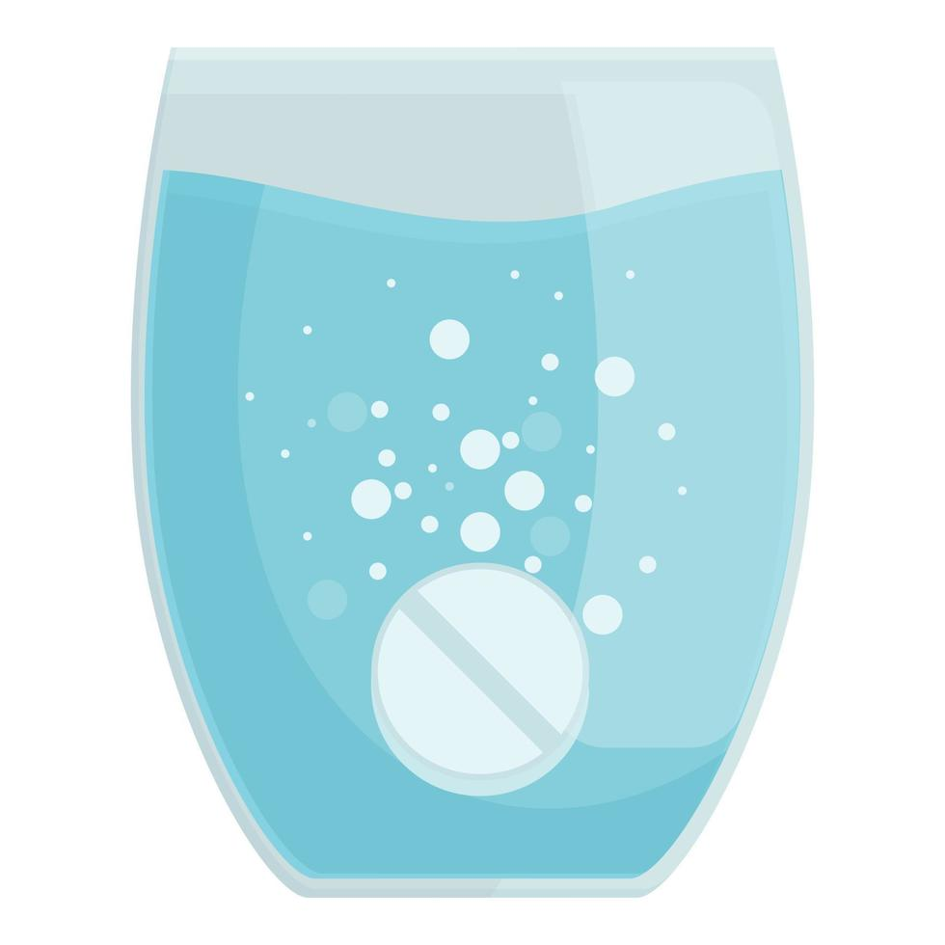
Using a graduated cylinder, measure 50 milliliters of 5% vinegar solution and pour it into the cup.
Cup 2 - Prepare the vinegar solution
Using a graduated cylinder, measure 50 milliliters of 5% vinegar solution and pour it into the other cup.
Experiment
- Alka Seltzer tablet preparation
Open the Alka Seltzer packet and place one of them on a weighing boat. Crush the other into a powder using a pestle and mortar. Then, transfer the contents into another weighing boat.
- Add dish soap
Add two drops or a small amount of dish soap to both cups. Then swirl to distribute the dish soap evenly within the solution.
- Add the Alka Seltzer to the cups
Add the whole Alka Seltzer to one cup and the crushed Alka Seltzer powder to the other cup at the same time.
- Observe both cups
Watch the rate and the amount of bubbles that form in each cup. Observe that the cup with the powdered Alka Seltzer has a large amount of bubbles forming quickly and there is a lot less in the other cup.

