


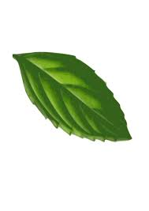
Battle of the Scents

Chemical Name | Amount Used
Canola oil | 12-13 mL per vial (24-26 mL total)
Deionized water | 12-13 mL per vial (24-26 mL total)
Any herb (ex: mint, basil, sage) | 2 leaves

Equipment Name | Number of Items
Plate/Piece of paper | 1
Scissors | 2
Screw top vials | 4

Vial 1 - Large mint piece in water
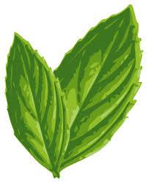
Cut a large piece of mint using scissors. Place the mint piece into a screw top vial. Add 12-13 milliliters of water to it. Screw the top on the vial and push the mint leaf under the water.
Vial 2 - Chopped mint in water
Cut a piece of mint of similar size to vial 1 and cut it into small bits. Transfer the bits into a new vial. Add 12-13 milliliters of water to it. Screw the top on the vial and push the mint leaf bits under the water.
Vial 3 - Large mint piece in oil
Cut another large piece of mint. Place the mint piece into a new vial and add 12-13 milliliters of Canola oil or an oil without its own scent. Screw the top on the vial.
Vial 4 - Chopped mint in oil
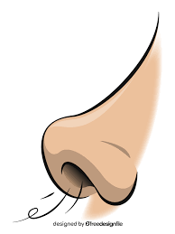
Cut a piece of mint of similar size to vial 1 and 3 and cut it into small bits. Transfer the bits into a new vial. Add 12-13 milliliters of Canola oil to it. Screw the top on the vial.
Experiment
- Shake the vials
Shake each vial very well. Ensure there is full contact between the mint leaves and the oil or water.
- Let the vials sit
Let each of the vials sit for 15 minutes before continuing with the rest of the steps.
- Simple smell test
Open the vials containing water one at a time. Smell each of them and compare the intensity of the mint smell. Decide which one has a stronger mint smell. Do the same with the vials filled with oil.

